Guidelines for authors submitting papers IF-ALL 2023
John Smith1, António Silva¹, Lorenzo Ortiz1, Aleksi Virtanen2
1 Faculty of Engineering University of Porto, Department of Electrical and Computer Engineering, Porto, Portugal
{john.smith, antonio.silva}@emailaddress.com
2 INESC-ID, Lisboa, Portugal
aleksi.virtanen@emailaddress.com
Abstract. Having a well prepared abstract should allow the reader to identify the basic content of the paper in a quick and accurate way. It should summarize the contents of the paper and have between 70 and 150 words. The font size should be set in 9-point and should be inset 1.0 cm from the right and left margins. We recommend using the provided styles in this documents by choosing the “JIM_Abstract” style.
Keywords. Authors should use keywords according to the AGROVOC thesaurus available online. Keywords must be separated by commas.

1 Section heading
Sample text inserted for illustration. Replace with article text, including headings where appropriate. Figures and tables should be single- or double-column width as appropriate, after they are first cited in the text.

1.1 Subsection heading

2 Preparing a paper
This document serves as an instruction file to authors willing to submit a paper to IF-ALL. This template is based on the one provided by the open-access Journal of Innovation Management (JIM).

3.1 Structuring a paper
There are many interesting resources online that may help authors to structure their paper. We suggest reading the resource from the TECHNISCHE UNIVERSITÄT WIEN, available in http://www.webcitation.org/5OIem27q6, that suggests the following structure:
- Title
- Abstract
- Keywords
- Introduction
- Related Work
- 2-4 main sections
- Results
- Conclusions (and Future Work)
- Acknowledgments
- References
- Appendix

3.2 About the File Format
The papers will be published in PDF. In any case, authors must submit their paper in Rich Text Format (RTF). Any common word processor is able to save the file in this format.

3.3 About the Layout and Style
This file has already defined styles for each type of content if you use the MS-Office Word processor. You should select the text and choose the style according to its type. For instance this text should be defined as JIM_text.
In case you are not using the MS Word processor you can follow the following instructions.
The name of the author(s) and the text in general should be set to 10 point font size, single line spacing and justified. Abstract and Keywords should be set to 9 points. The font used should be set to Times New Roman. Authors may use italic to emphasize words and bold and underlining should be prevented. Papers that do not comply with this format may be reformatted, therefore this can lead to an increase in the number of pages.
Headings. Headings should follow this template and are summarized in the following table:
Table 1. Font sizes of headings. Table captions should always be positioned above the tables and set to 9 points font size with no paragraph space after.
Heading level | Example | Font size and style | Paragraph space
Title (centered) | Lecture Notes | 14 point, bold  JIM_Title | 12 pts after
1st-level heading | 1 Introduction | 12 point, bold  JIM_H1 | 12 pts after and 18 pts before
2nd-level heading | 2.1 Printing Area | 10 point, bold  JIM_H2 | 9 pts after and before
3rd-level heading | Headings. Text follows … | 10 point, bold  JIM_H3 | 3 pts after and before
4th-level heading | Remark. Text follows … | 10 point, italic  JIM_text (with Italic 1st word) | 3 pts after and before
Figures. Figures must be numbered and its caption should be placed below the image and set to a font size of 9 points. Authors are responsible for the quality of the figures inserting but we strongly advises to use images that have quality enough for printing purposes (at least 800 dpis). Please avoid the use of shading and be reasonable with the size of text and width of lines, the figure must be undoubtfully legible, thus contrast should be as pronounced as possible. Avoid at all cost the use of colored figures. Please attend to the following example:
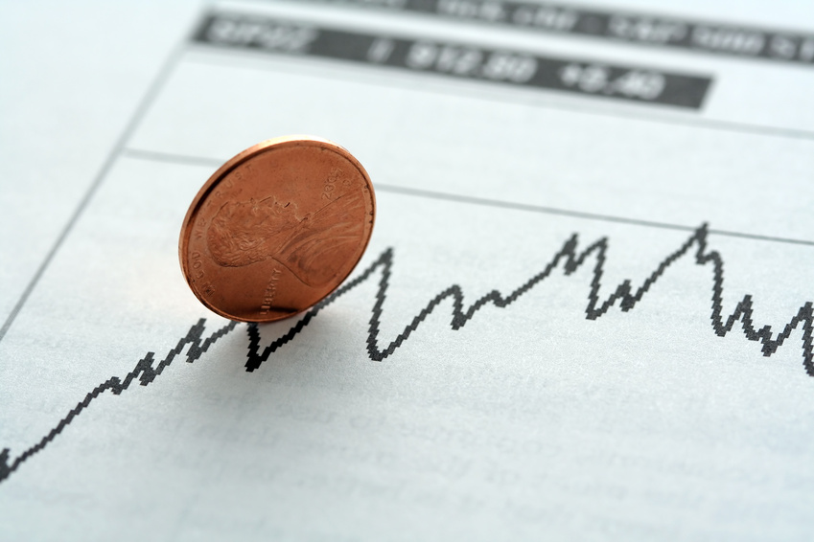
Fig. 1. Figure as an example. This shows a figure consisting of different types of lines. Elements of the figure described in the caption should be set in italics, in parentheses, as shown in this sample caption.
Formulas. The use of formulas within the text should be in a separate line and centered. Displayed expressions must be numbered in the caption, which should be set in the same line as the formula, enclosed in parentheses and right margined as the following example:
a2 + y² = z . | (1)
Citations. When citing authors should use the author-date system, which means including in the text and between curved brackets, the last name of the authors and the date – example (Smith, 2005).
Acknowledgements. If the authors want to dedicate a chapter to acknowledge something or someone, they should structure the paper so that this acknowledgments appear before the References.
Appendices. In case there are any appendices to include in the paper, they must be presented after References with the heading “Appendix”.

4 Checklist submission
- Contacts information:
- E-mail
- Postal address
- Telephone or Mobile number
- Keywords
- All figure and table captions
- References are according the template provided and cited in the text
- The paper has been spellchecked and grammar-checked
- References are in the correct format for this journal (APA Style)
- Any material with copyright has been authorized by the owner

5 References
For referencing as for citations, this template follows the APA Style, available online (http://www.apastyle.org/index.aspx) for further reading. The reference list should be arranged alphabetically. We provide some examples of different types of documents referenced (books, scientific journal article published in an electronic journal, Book editor(s); chapter with own author, scientific journal article in a printed journal and a URL):
Cummings, J. N., Butler, B., & Kraut, R. (2002). The quality of online social relationships. Communications of the ACM, 45(7), 103-108.
Hu, Y., Wood, J. F., Smith, V., & Westbrook, N. (2004). Friendships through IM: Examining the relationship between instant messaging and intimacy. Journal of Computer-Mediated Communication, 10(1), 38-48.
Tidwell, L. C., & Walther, J. B. (2002). Computer-mediated communication effects on disclosure, impressions, and interpersonal evaluations: Getting to know one another a bit at a time. Human Communication Research, 28(3), 317-348.
Phillips, S. J., Whisnant, J. (1995). Hypertension and stroke. In J. H. Laragh, & B. Brenner (Eds.), Hypertension: pathophysiology, diagnosis, and management (pp. 465-78). New York: Raven Press
Borman, W. C., Hanson, M. A., Oppler, S. H., Pulakos, E. D., & White, L. A. (1993). Role of early supervisory experience in supervisor performance. Journal of Applied Psychology, 78, 443-449. Retrieved October 23, 2000, from PsycARTICLES database.
Chou, L., McClintock, R., Moretti, F., Nix, D. H. (1993). Technology and education: New wine in new bottles: Choosing pasts and imagining educational futures. Retrieved August 24, 2000, from Columbia University, Institute for Learning Technologies Web site: http://www.ilt.columbia.edu/publications/newwine1.htm

