PARADISE HOTEL BUSAN  RESERVATION FORM |  | The 5th CORDEL Regional Workshop  21-22, May. 2024 |  |  |  |  |  | 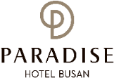
1. GENERAL INFORMATION |  |  |  |  |  |  |  | 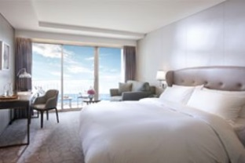  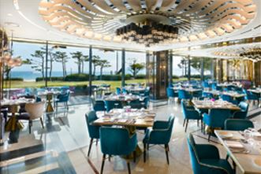  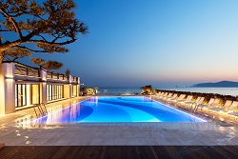
*Check-In Date: |  |  |  | *Check-Out Date:
*Name(Family/Given): |  |  |  | *Number of Persons:
*Telephone: |  |  |  | *E-mail:
2. CREDIT CARD GUARANTEE
*Credit Card: ☐Visa, ☐Master, ☐Amex (4Digital number: ), ☐Other( )
*Card Number: |  |  |  |  | *Signature:
*Expiry Date(mm/yy):
*Holder’s Name:
The above card information is used for the guarantee of your reservation only, and the payment will be made upon check-in.
I agree that using the above credit card information to be used in relation to cancellation fees and the occurrence of the No-Show.
상기 카드 정보는 예약 보증을 위해서만 사용되며, 위약금 발생 시에만 사용하는 것에 동의합니다. 실제 결제는 체크인 시 현장에서 진행됩니다.
3. SPECIAL ROOM RATE (UNIT: KOREAN WON)
Room Type |  |  | *Monday - Thursday |  |  | *Friday | *Saturday |  | *Sunday
Main Bldg. | Deluxe City View |  | ☐ 242,000 (King Bed)  ☐ 242,200 (Twin Bed) |  |  | Surcharge  +72,600  (추가요금) | Surcharge  +157,300  (추가요금) |  | Surcharge  +36,300  (추가요금)
Annex Bldg. | Deluxe City View |  | ☐ 266,200 (King Bed)  ☐ 266,200 (Twin Bed)
Annex Bldg. | Deluxe Ocean View |  | ☐ 290,400 (King Bed)
Main Bldg. | Deluxe Ocean Terrace View |  | ☐ 314,600 (King Bed)  ☐ 314,600 (Twin Bed)
Annex Bldg. | Deluxe Ocean Terrace View |  | ☐ 338,800 (King Bed)  ☐ 338,800 (Twin Bed)
*Extra Bed(Main Bldg.) or Extra Bedding(Annex Bldg.): KRW 72,600(Per Night)
*Breakfast Buffet (Main Bldg. 1F. On the Plate, 06:30-10:00): KRW 50,000(Per Person)
*Special Request:
The rates above are non-commissionable, and they are Inclusive of 10% Service Charge and 11% Government Tax.
The rates above are not inclusive of breakfast.
Number of guests: 2 Adults. All rooms of the Building are non-smoking areas.
Check-in time is 3p.m.(15h00) Check-out time is 11:00 a.m.(11h00). Past the mentioned check-out time, the following rates will be applied
(Until 3p.m.(15h00): 50% of the room rate, After 3p.m.(15h00): 100% of the room rate)
Benefits Included: Outdoor Ocean pool(Swimming pool), Fitness Club, Business Center, Kids Villages, Wi-Fi
The Leisure facilities (Ocean Pool, Fitness Club, Sauna, Spa Cimer) will be closed for maintenance every fourth Wednesday each month.
상기 객실 요금에는 봉사료 및 세금이 포함되어 있으며, 조식은 별도입니다. 전 객실은 금연 객실로 지정되며, 체크인은 15시, 체크아웃은 11시입니다.
기준 투숙 인원은 성인2인이며, 야외수영장, 피트니스클럽, 비즈니스센터, 키즈빌리지 무료 입장이 가능합니다. 매월 4주차 수요일은 레저시설 휴무입니다.
CANCELLATION POLICY
Amendaments, Cancellations are availble upon following regulations: Hotel has the right to claim all room charge, which would be deducted from your guaranteed credit card. Cancellation or No-Show after the room reservation is being charged as below:
1) From 5days to 3days prior to Arrival date(~18:00): 50% of the Room charge
2) From 2days or less prior to Arrival date(Includling No-Show): 100% of the Room chrarge
위약금 규정 1) 체크인 5일 전~3일 전 취소시 위약금: 객실료의 50% 부과, 2) 체크인 2일 전~당일 취소 시(노쇼포함): 객실료의 100% 부과됩니다.
Please send your reservation form to: res@paradian.com (Tel. +82-51-749-2111~3)

