Title No More Than 2 Lines. Use Style “Title” or 14 pt Arial, Initial Caps, Bold, Centred
Author Name, Position, Company
Author Name, Position, Company
Author Name, Position, Company
abstract
Use style “NORMAL” or 10pt Arial not bold. 0pt before and 8 pt after. Single line spacing. Left aligned
No more than three paragraphs.
Should be a brief overview of the project purpose, methodology, learnings and outcomes. Details should be provided in the body of the paper, not here.

Introduction – use style “Heading 1” or 12pt arial bold, all caps, Left aligned
Use style “NORMAL” or 10pt Arial not bold. 0pt before and 8 pt after. Single line spacing, Left aligned
Describe the problem that your project was designed to solve and an overview of the project itself. The rest of the paper should flow on from here..

Heading 2 – Use style “Heading 2” or 12 pt Arial bold. Numbered list with no indenting and second level, Left Aligned
Use style “NORMAL” or 10pt Arial not bold. 0pt before and 8 pt after. Single line spacing, Left aligned

Heading 3 – Use style “Heading 3” or 12 pt Arial bold. Numbered list with no indenting and third level, left aligned
Use style “NORMAL” or 10pt Arial not bold. 0pt before and 8 pt after. Single line spacing, Left aligned
- Use Bullet1 style or use 12pt arial. No indent. 0.63cm hanging indent. No space between bullets. 8pt space after last bullet. Symbol decimal 183 as bullet. Left Aligned
- Use Bullet2 style or use 12pt arial. .63cm indent. .63cm hanging indent. No space between bullets. 8pt space after last bullet. Symbol decimal 45 as bullet, Left aligned

CONCLUSION
Use style “NORMAL” or 10pt Arial not bold. 0pt before and 8 pt after. Single line spacing, Left aligned

REFERENCES
- Ref1 - use style “bullet 1”
- Ref2

ACKNOWLEDGEMENTS
Use style “NORMAL” or 10pt Arial not bold. 0pt before and 8 pt after. Single line spacing. Left aligned

AUTHOR BIOGRAPHY/IES
Author Name is a position name with organization name. Years and type of experience. Key achievements/responsibilities. No more than 200 words.

INSTRUCTIONS ON USE OF TABLES AND FIGURES (PHOTOGRAPHS, DRAWINGS AND CHARTS)
The above document structure is to be adhered to. The figure (graphics) and table examples below are for your guidance. Add where required.
Note. Be aware if you copy graphics or tables in from other documents you will also copy any styles used by those graphics and tables which will then also appear in this document’s style list. Please ensure that you do not use these imported styles anywhere else in the document. Just do your best to keep the document as consistent and readable as possible.
Graphics/IMAGES/PHOTOGRAPHS etc
Figure n Add this text below graphic or chart. Use style “graphic” or 9pt arial, bold, centred. 0 pt before and 8 pt after. Update figure number manually.
Graphics should not bleed into the margins. Margins are 2.54cm left and right.
Example graphics
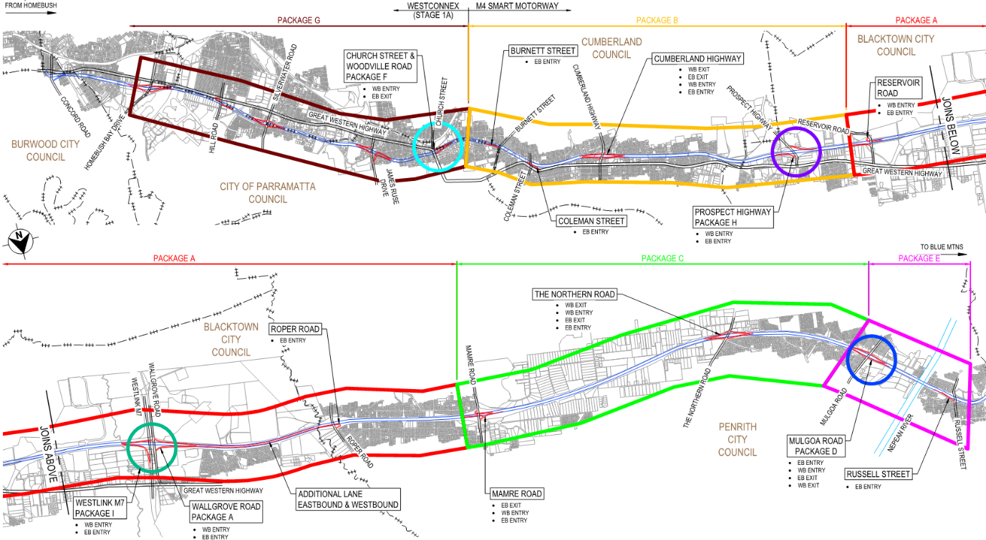
Figure 1- M4 Smart Motorway project extent
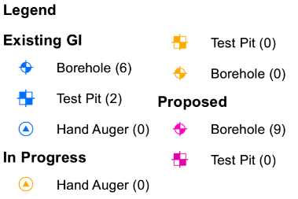
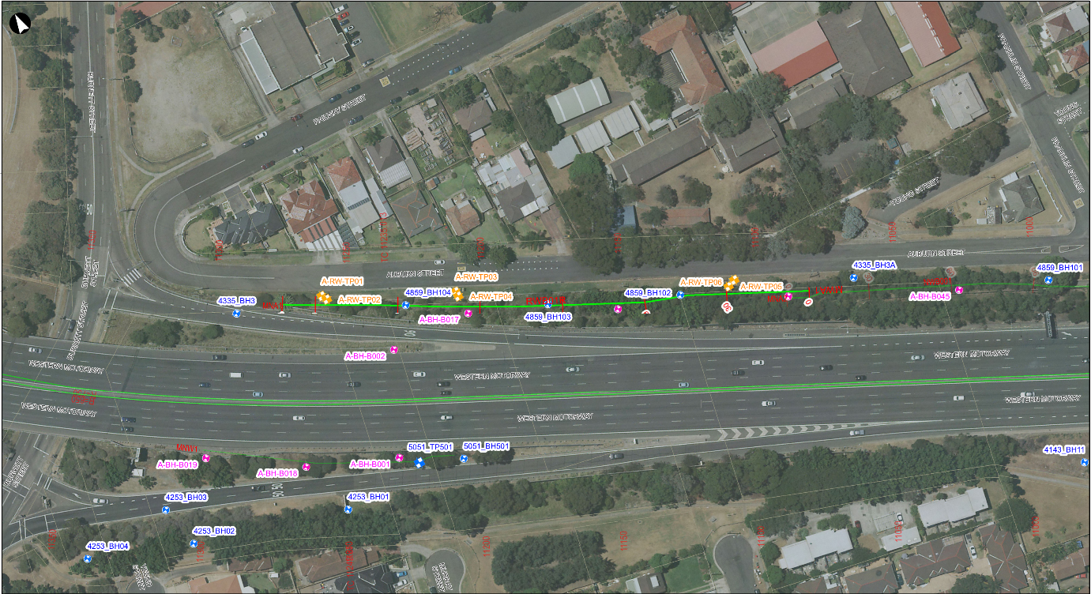
Figure 2- Location Plan RW1
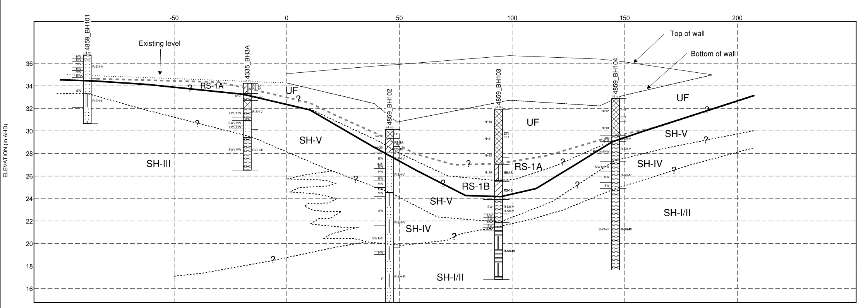
Figure 3- Inferred geotechnical section along RW1
Tables
Design as required but use 12pt arial as text, left aligned except when spans more than one column, then centre. Use as many columns as you need bearing in mind readability. Note that table should not bleed into the margins. Margins are 2.54cm left and right. If cells are higher than normal then centre vertically. Headings should be bold.
Table n: Add above table. Use style “Table Title” or 10pt arial, bold, left aligned, 0 pt before and 8 pt after. Update Table number manually. Left aligned
Heading 1 | Heading 2 | Heading 3 | Heading 4 | Heading 5
Table Text | Table Text | Table Text | Table Text | Table Text
Table Text | Table Text | Table Text | Table Text | Table Text

Heading merged vertically | Heading merged horizontally, centred
 | Heading 1 | Heading2 | Heading 3 | Heading 4
Table Text | Table Text | Table Text | Table Text | Table Text

Example tables
Table 1: Geotechnical design parameters for soil support structures
Geological Unit ID ¹ | Material | Moist Bulk Unit Weight, $γ$ (kN/m³) | Undrained Shear Strength,  Su (kPa) | Cohesion  c' (kPa) | Effective Friction Angle, $φ'$($°)$ | Drained Elastic Modulus, E’ (MPa)
EF1 | Engineered Fill (Cohesive) | 18 | 75 | 5 | 28 | 15
EF2 | Engineered Fill (Granular) | 20 | - | 0 | 33 | 60
RS-1A | Residual Soil (Stiff) | 20 | 50 | 5 | 26 | 15
Notes: 1. Rock classes are in accordance with Pells et al. (1998)
Table 2: Burnett Street Eastbound Entry Ramp Bored Pile details
Description | CH 0 to CH 30 | CH 30 to CH 160 | CH 160 to end
Retaining Wall RW1
Maximum retained height | 3.9 | 5.6 m | 3.4
Min wall stem thickness | 900 mm | 900 mm | 900 mm
Foundation cast-in situ bored piles
Pile Length | Min 6 m | Min 11 m | Min 8 m
Pile Diameter | 750 mm | 900 mm | 750 mm

Table 3: Anticipated displacements at the top of steep soil nail walls
Empirical correlations | Soil type
 | Weathered rock/Stiff soils | Sandy Soils | Clayey Soils
Δx=Δy⁽¹⁾ | H/1000 ⁽²⁾ | 2H/1000 | 3H/1000
Coefficient⁽³⁾ (k) | 0.8 | 1.25 | 1.50
Notes: 1. Δx and Δy are horizontal and vertical displacements at top of wall, respectively.
2. H is retained height.
3. Horizontal displacement behind soil-nailed block is estimated as
Δ₀=k(1-tanφ’).H

