Dear < supervisor’s name >,
I would like to represent our organization by attending the AISAP Virtual Institute from July 12-15 2021. The Institute is the only gathering of Admission and Enrollment Professionals focused solely on the art and the science of my profession.
AISAP has gathered practitioners and experts from around the globe to educate the profession on the essential elements and aspects of the work of Admission and Enrollment. As you know, this is a critical time where the challenges and implications of success in the area of enrollment are paramount. I feel this is an excellent opportunity to learn about the latest in the independent and private school admission and enrollment community, participate in tactical training, and network with organizations and colleagues from around the world.
Since the event is virtual this year, there are no travel and related expenses to the Institute. Furthermore, AISAP has reduced the rate of this event in recognition of the present economic challenges for schools as a result of the COVID pandemic. Here is the cost breakdown:
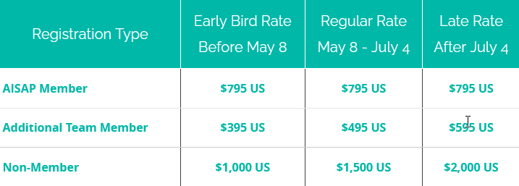
Thank you in advance for considering this request!
Sincerely,

