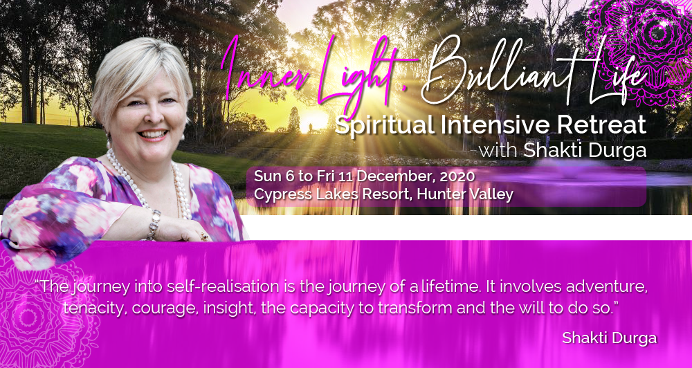

Accommodation Options

Single Room in 2-bedroom apartment AUD$2,651.00

Single room with ensuite. Kitchen and lounge room for comfortable living. Includes vegetarian breakfast and lunch.

Please note the apartments have two bedrooms each of which can be a single or a twin share. The single option gives the participant a room to themselves in a two-bedroom apartment where the other bedroom will be occupied by either another person who chose a single or two people who chose twin. Similarly, with twin option, the participant will be sharing a room with another participant in one room and will have either one or two people in the other bedroom.

Twin Share in 2-bedroom apartment AUD$2,265.00
(We would ask that if you snore to please consider a single room so as not to disturb other retreat participants)

Twin share room with ensuite. Kitchen and lounge room for comfortable living. Includes vegetarian breakfast and lunch.

Please note the apartments have two bedrooms each of which can be a single or a twin share. The single option gives the participant a room to themselves in a two-bedroom apartment where the other bedroom will be occupied by either another person who chose a single or two people who chose twin. Similarly, with twin option, the participant will be sharing a room with another participant in one room and will have either one or two people in the other bedroom.

