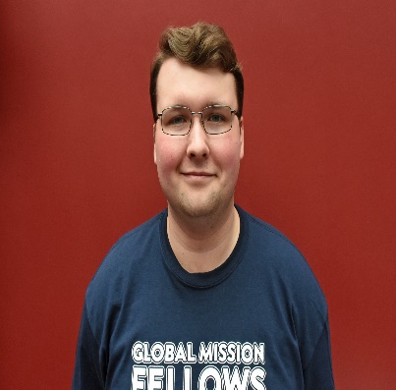

**Global Mission Fellow:**International

**Global Mission Fellow:**International

**Global Mission Fellow:**International

**Global Mission Fellow:**International

To support

ehunter@umcmission.org

Advance #3022634

To support

ehunter@umcmission.org

Advance #3022634

To support

ehunter@umcmission.org

Advance #3022634

To support

ehunter@umcmission.org

Advance #3022634

**Erick**

**Park**

**Hunter**

**Erick**

**Park**

**Hunter**

**Erick**

**Park**

**Hunter**

**Erick**

**Park**

**Hunter**

