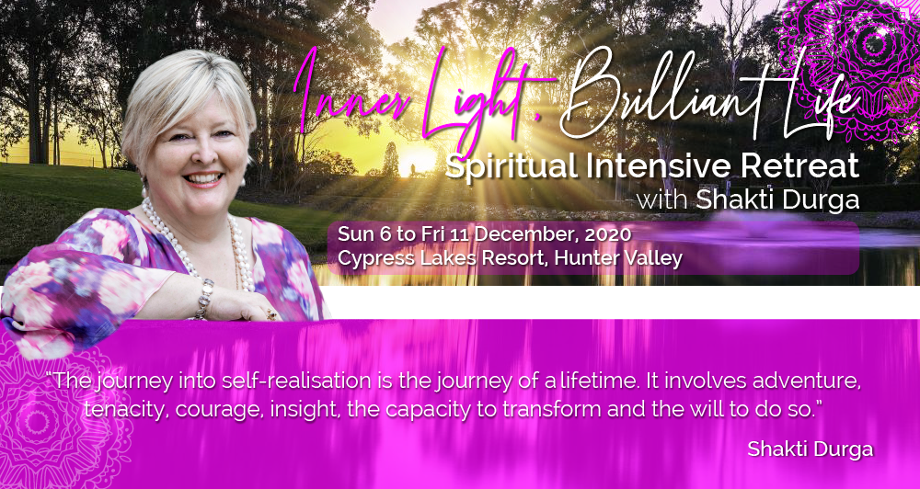

No Accommodation Options

Full Retreat No Accommodation AUD$1,878.00

Full attendance at the retreat, no accommodation provided. Includes vegetarian breakfast and lunch.

One Day attendance at the Retreat, No Accommodation AUD$499.00

This option allows the participant to attend the Sunday afternoon session on 6 December as well as the full day on Monday 7 December. Includes vegetarian breakfast and lunch on the Monday only.

Two Days attendance at the Retreat, No Accommodation AUD$998.00

This option allows the participant to attend the Sunday afternoon session on 6 December as well as the full day on Monday 7 December and Tuesday 8 December. Includes vegetarian breakfast and lunch on the Monday and Tuesday only.

Three Days attendance at the Retreat, No Accommodation AUD$1,497.00

This option allows the participant to attend the Sunday afternoon session on 6 December as well as the full day on Monday 7 December, Tuesday 8 December and Wednesday 9 December. Includes vegetarian breakfast and lunch on the Monday, Tuesday and Wednesday only.

